Diocese of Cleveland CYO Play Like a Champion Today Initiative Benefitting Your Program

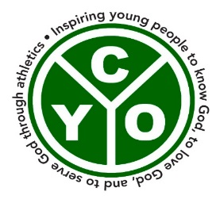
Play Like a Champion Today provides education and
Leadership training to become ethically responsible
Coaches, athletes and parents in
An effort to renew the culture of youth sports.
Play Like a Champion Today [PLACT]
- Teaches the spiritual nature of sports
- Trains coaches to promote moral growth of their athletes
- Researched-based, child-centered curriculum

Choosing PLACT will train your program to bring the message of the Gospel to your coaches, your athletes, your parents and create a Team of Champions. Pope Francis reminds us that all organizations have a responsibility to invest in, and continue to prepare coaches to live, model and be driven by the mission, values and virtues that empower young people to deepen their relationship with God. With continued training, your coaches will learn how to transform your athletes to become disciples.

Elevate your Program with a PLACT program:
- Select a date
- Select a location at your site
- Contact CYO
- Invite your coaches
- CYO sends a PLACT trainer to your site
- Two-hour session with our trainer, your coaches

CYO PLACT Trainers:
- Dr. G. Dobie Moser, co-wrote the curriculum
- Trains each trainer

After your coaches are trained, the education continues. Practical applications to elevate your program and alter your culture will be provided through ongoing communications from the headquarters at the University of Notre Dame.
- Champion Coach’s Note - weekly
- Champion Athlete & Parent Note - twice monthly
- Champion Athlete Note - twice monthly

Michael Strumbly at mrstrumbly@ccdocle.org

What is PLACT?

Why PLACT?

Becoming a PLACT Program

Trainers

Continuing Education and
Support

Contact

